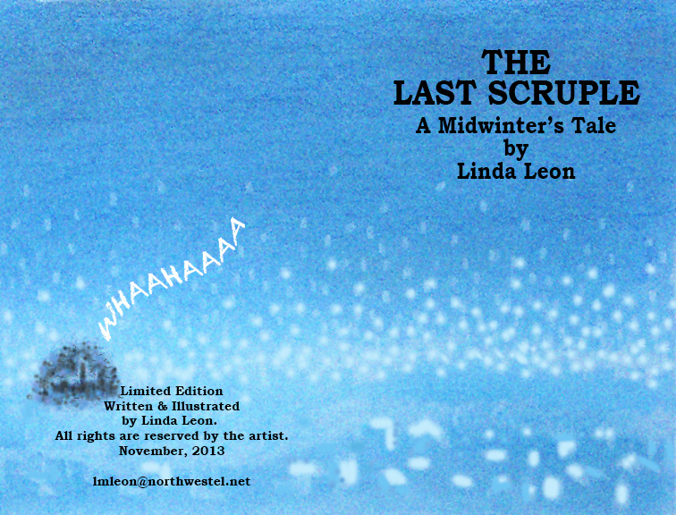

THE LAST SCRUPLE - A Midwinter’s Tale

Copyright
COPYRIGHT 2014 BY LINDA LEON
First Edition
All rights reserved. The use of any part of this publication reproduced, transmitted in any form or by any means, electronic, mechanical, photocopying, recording, or otherwise, or stored in a retrieval system without the prior written consent of the author is an infringement of copyright law.
Library and Archives Canada Cataloguing in Publication is available upon request.
ISBN 978-0-9936631-0-9
http//www.lulu.com

Preface
“My dear, the House of Commons is for moaning and groaning. It is for howling and screaming. It is for gnashing of teeth. But for weeping and wailing, you must try the Senate.”
The Last Scruple – A Midwinter’s Tale is an illustrated political bedtime story inspired by the antics of Canadian politicians and senators. The Parliament buildings have become a place of dark disorder. Canada’s Better Angel seeks to find the source of weeping that only she can hear.
The Last Scruple was originally created in 2010 as an illustrated theatrical performance. It was written in response to the killing of the Climate Change Accountability Act and the unprecedented underhanded way Conservative Senators carried out this action. The characters of Senators Wallin, Duffy, Lebreton and Gerstein were featured in the original play even though the current Senate scandal had yet to become news.
I would like to thank the Prime Minister who continues to provide inspiration for not only this book but for many other art projects.
Linda Leon

Whahaaaaaaaaaaaa!

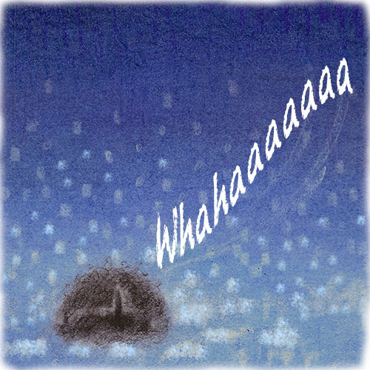

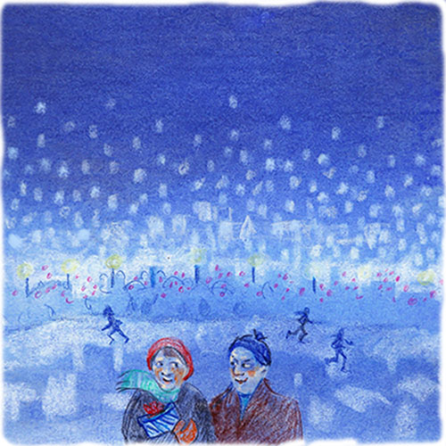
Ottawa was blanketed in a soft mantle of snow. Skaters glided along the canal. Shoppers hurried by, their cheeks flushed with good cheer.

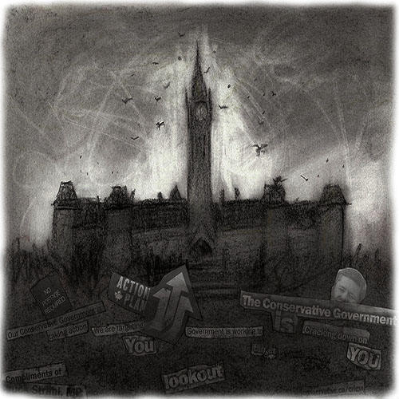
But the Parliament Buildings were immune to these mid-winter graces. They sat under their own black cloud, sullen and stained.

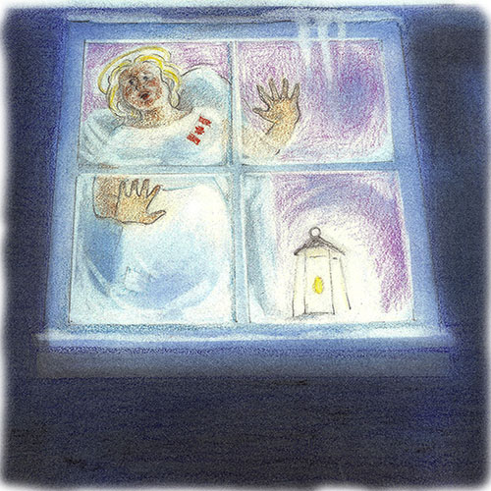
Canada’s Better Angel scratched the frost off her window. She peered into the night. Somewhere, someone was crying.
It is a well-known fact that better angels have exceptional hearing.
“Whahaaaaaaa!”

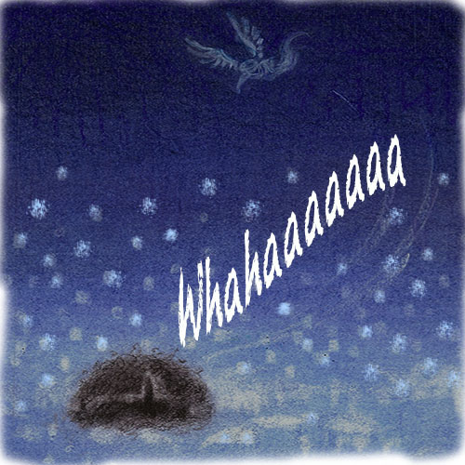
It appeared to come from the Parliament Buildings.

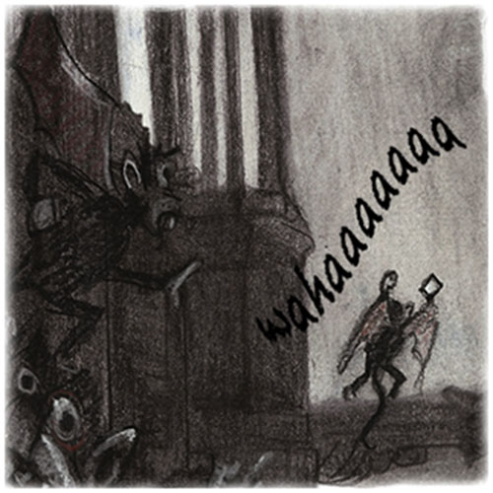

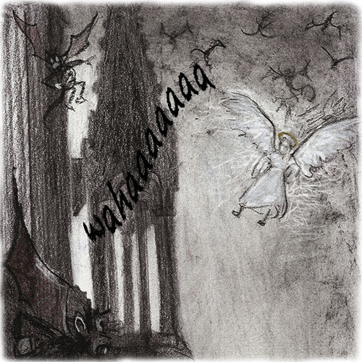

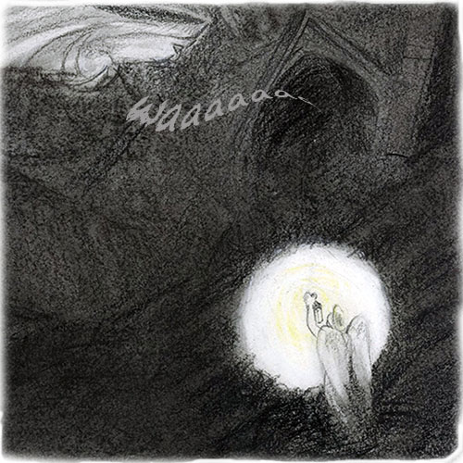
The entrance to the Peace Tower gaped ominously.

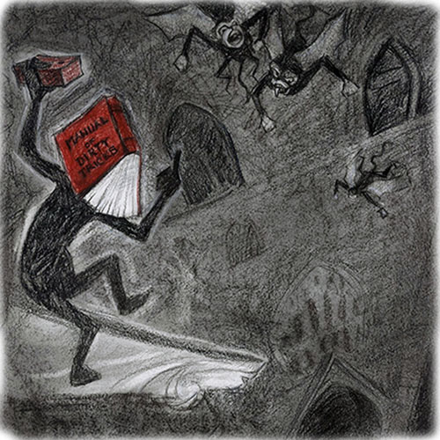

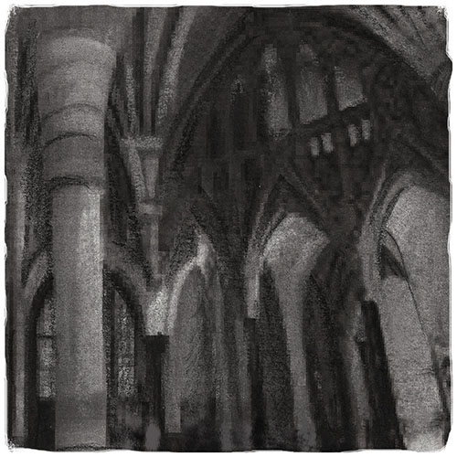
Better Angel slipped into the Rotunda and looked around. The hall was cold and empty, closed for the Holidays.

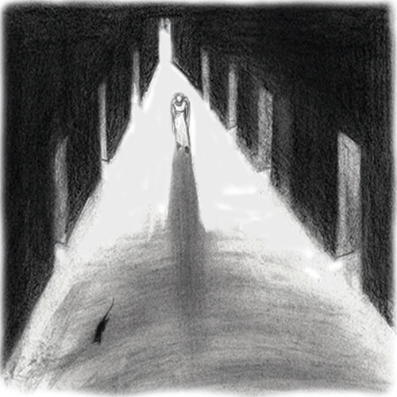
She moved along hallways.

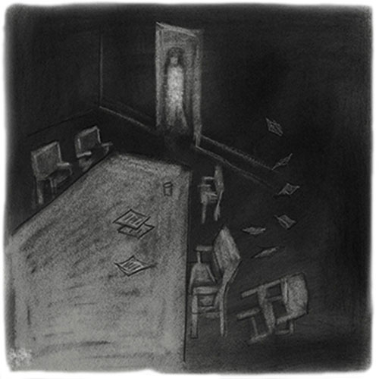
She peeked into committee boardrooms. Not a sound, just the smell of defeat.
Canada’s Better Angel found herself in the private corridor now known as the portrait gallery of terror. The Prime Minister’s eyes, multiplied 83 times, bored into her as though to say, “No one comes here without my permission. No one speaks without my permission.”
It was deathly quiet! Nothing stayed alive in this place for long.

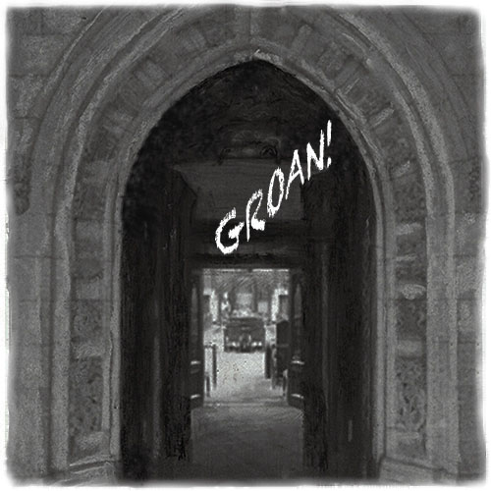
Better Angel heard a deep groan. It came from the House of Commons.

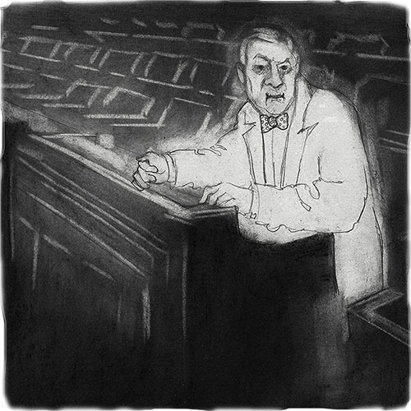
She walked into the House of Commons. The Speaker’s Chair sat empty. But there in his old seat sat the ghost of Lester Pearson. He turned his sad face towards Better Angel.
“Mr. Prime Minister, someone is crying.”
“My dear, the House of Commons is for moaning and groaning. It is for howling and screaming. It is for gnashing of teeth. But for weeping and wailing, you must try the Senate”.

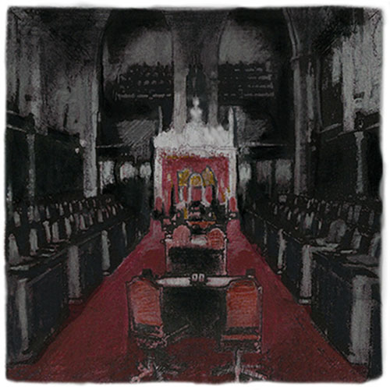
The Senate Chamber sat empty. Not a whisper.

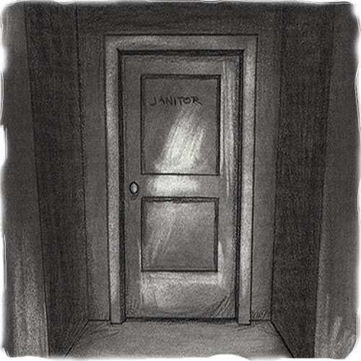
Then she heard it. Not a cry. Not a groan. It was the tiniest of sighs coming from a broom closet.
The door was locked. Using her celestial strength, Better Angel wrenched it off its hinges.

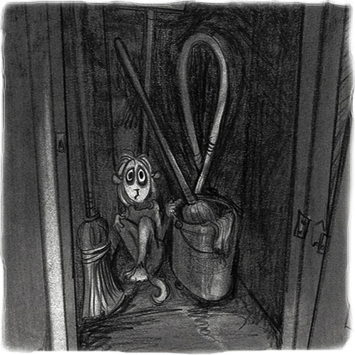
There in the corner amongst the mops and buckets, lay the last Senate Scruple.

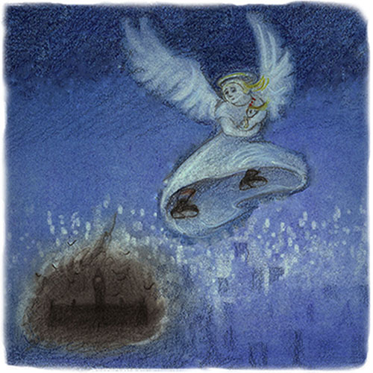
Canada’s Better Angel scooped up the tiny creature. She flew down the cavernous halls, out of the Parliament buildings and into the night sky over Ottawa.

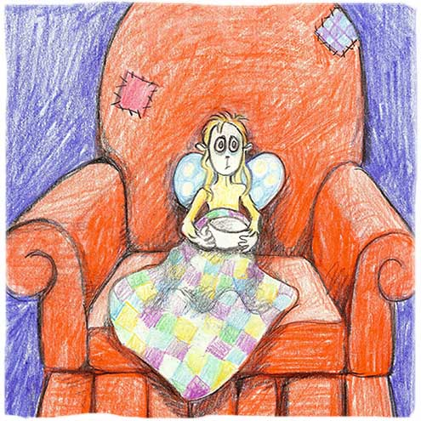
Later, safely ensconced in Better Angel’s tiny room, the last scruple told her sad, sad tale.

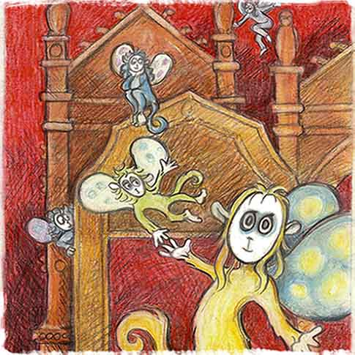
Sharon, for that was the poor creature’s name, had always lived in the Red Chamber. She belonged to a large clan of scruples who frolicked amongst the Senators as they pursued their goal of sober second thought. Not all Senators liked scruples. Nevertheless, this was the scruples’ natural environment and they flourished there.

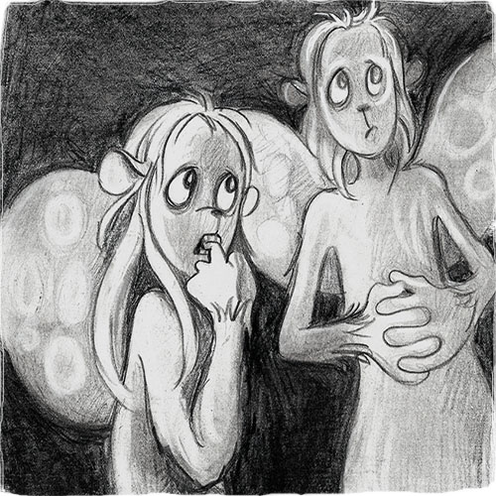
But dark days had come. Scruples were no longer tolerated in many parts of Canada. The city of Toronto had declared scruples, along with Intelligent Thought, to be noxious pests. Quebec’s new Charter stated that government employees could no longer display their scruples at work. And scruples were absolutely banned from the tar pits of Alberta.
The Red Chamber quickly became a dangerous place. All those with personal scruples kept them safe at home.

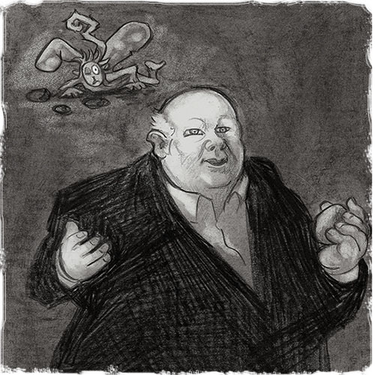
Senator Duffy was discovered throwing rocks at a scruple one afternoon.
“I was only teaching it to fetch. I’ve done nothing wrong.”

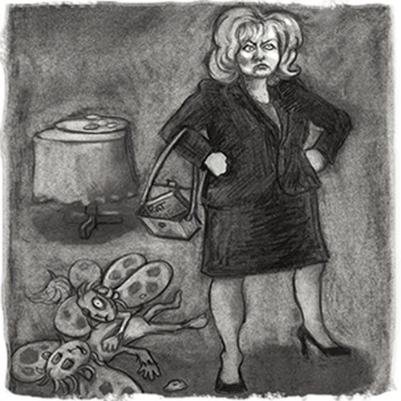
Senator Wallin fed the scruples cookies laced with rat poison.
“I have no idea how that happened. It could only be a plot by other jealous senators to discredit me. You know, the Prime Minister always loved me best.”

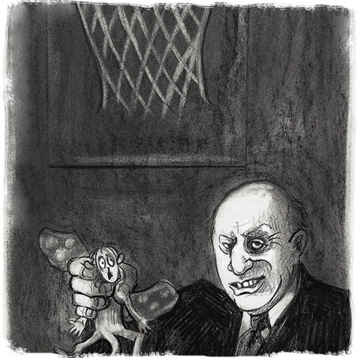
Senator Gerstein organized basketball games during breaks. “It’s all in the bag net. It’s a slam-dunk. I am not ashamed. I have nothing more to say.”

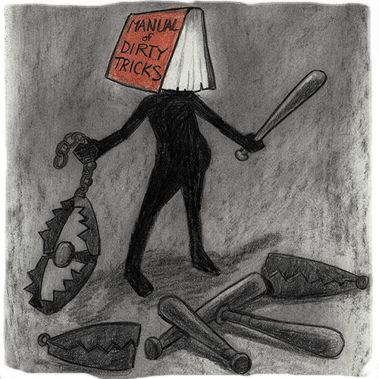
Senator Manual-of-Dirty-Tricks was seen handing out bear traps and baseball bats.

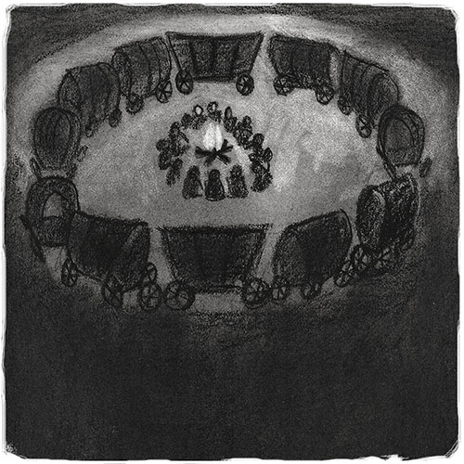
Caucus circled their wagons. The government house leader said, “We have heard from our base who are of the resounding point of view that we must remove the scruple threat once and for all”. The Environment Minister said that scruples must be “streamlined” for the sake of efficiencies. The Public Safety Minister said that tolerance of scruples would soon lead to pedophilia. Caucus agreed. They sent a barrage of e-mails to their constituents describing scruples as “anti-trade and anti-prosperity”, “terrorists” and “killers of Canadian families”. The Parliamentary Secretary, speaking for the Prime Minister, said that scruples were a serious threat to a strong, stable national majority government. An aide worried out loud that the inner circle “should not compromise themselves”. Caucus told him to “shut up, stay on message and stick with the script.” The chair of the Senate Committee on Internal Economy concluded the meeting with, “I know nothing.”

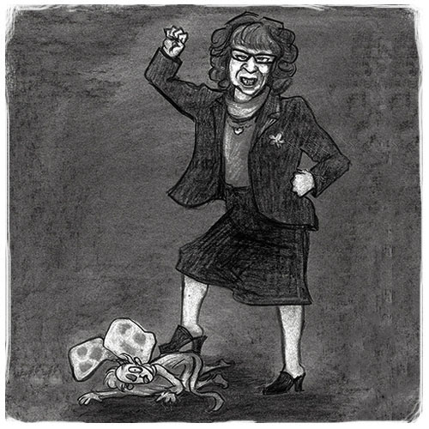
Reporters continued to ask questions about the fate of scruples. Senator Marjorie LeBreton hissed and spat.

“You liberal elites! You media lickspittles!”

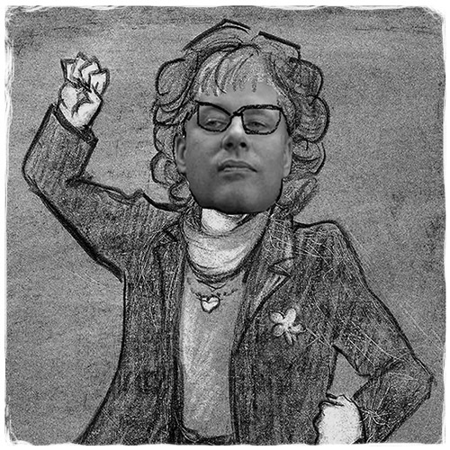
Observers were shocked to notice that Senator LeBreton spoke with the same voice as the Prime Minister.

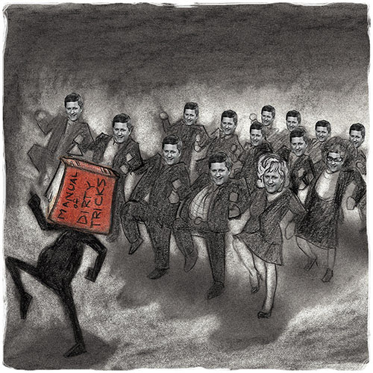
Indeed, all of the new senators spoke with the Prime Minister’s voice as they marched lock step down the hall to murder the remaining scruples.
“Bagmen march along the hall,
hurrah, hurrah!
Rules don’t apply to us at all,
Hurrah, hurrah!
Bagmen march along the hall.
We don’t give a hoot,
We’ll give them our boots
as we all go marching
down the hall
To kill them all.”

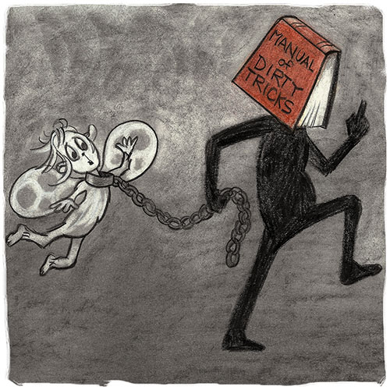
Within weeks, the scruples were gone. Only Sharon remained having fallen into the clutches of Manual-of-Dirty-Tricks, the most heartless and cruel of all the Senators. He kept her alive for the pleasure of torturing her with expense claim fiddles, ominous budget bills, hate ads and electoral crimes.

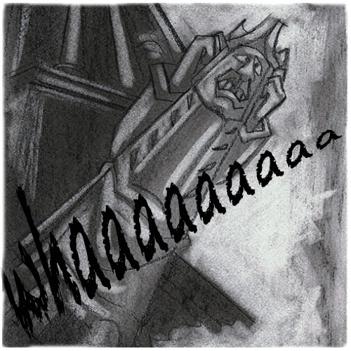
Sharon’s wails echoed down the stone hallways, filled the rotunda and made the gargoyles on the Peace Tower wince.

“Whaaaaaaaaa!”

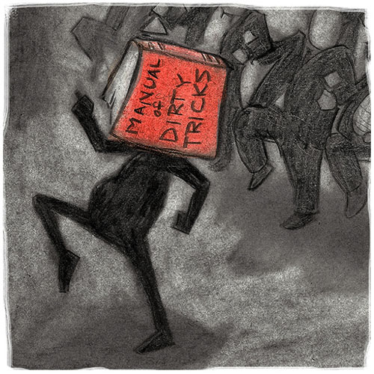
Now, it was a strange happenstance that members of caucus were unusually small people. Senator Manual-of-Dirty-Tricks was the smallest of them all. And because he was so very very small, he hated anyone who towered above him.
Manual-of-Dirty-Tricks hated the Parliamentary Budget Officer most of all.

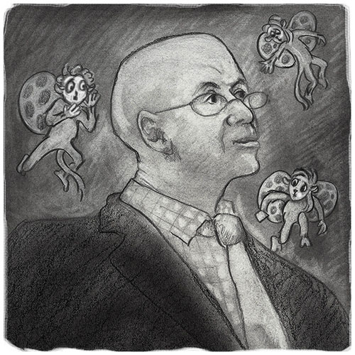
The Parliamentary Budget Officer was so very tall that he could keep his personal scruples with him. They flew about his shoulders, well above harm’s way.

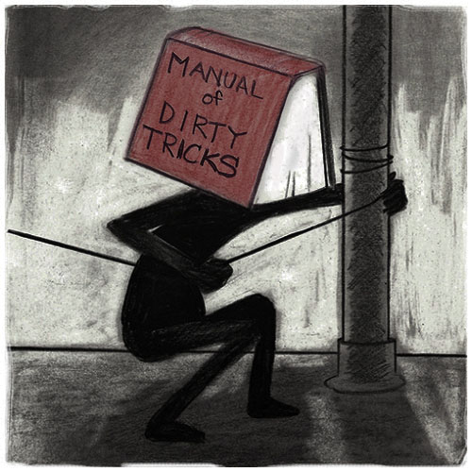
One day, Manual-of-Dirty-Tricks devised an evil plan to trip the Parliamentary Budget Officer in the staircase. He strung piano wire across a landing.
“Stupid giant; this will learn him. Heh, heh, heh!”

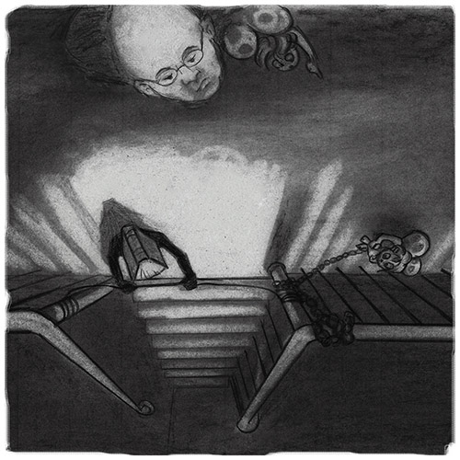
Now, it is a well-known fact that giants are far sighted. The Parliamentary Budget Officer could see Manual-of-Dirty-Tricks and his trap.

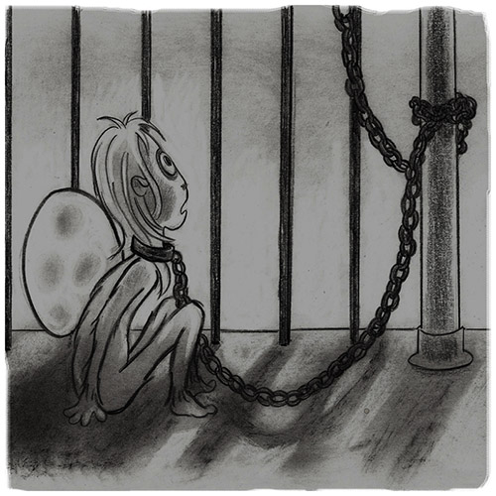
He could see the tiny scruple with her chains.

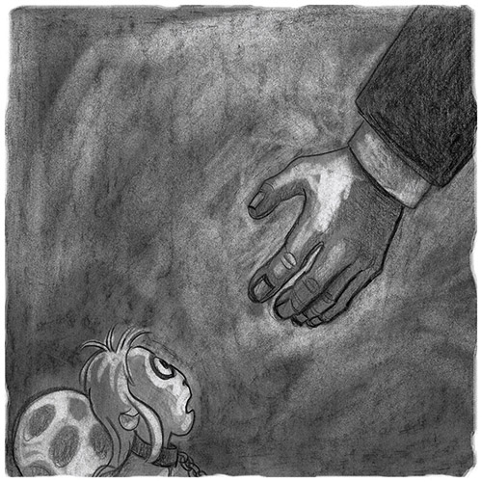
The Parliamentary Budget Officer reached way, way down with his very long arms. He broke Sharon’s chains.

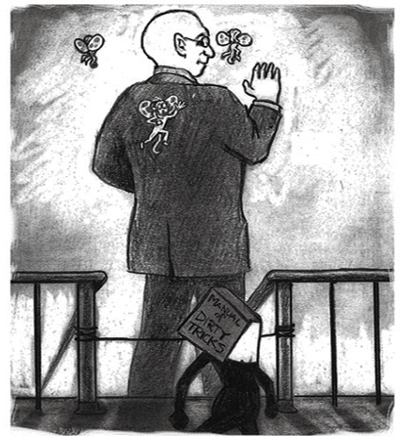
Stepping well over the strung wire with his very long legs, the Parliamentary Budget Officer wished Manual-of-Dirty-Tricks a cordial “Bon soir” as he continued safely down the stairs.
At first Manual-of-Dirty-Tricks was stunned. Had disloyal civil servants given him away? Were they not sufficiently cowed?

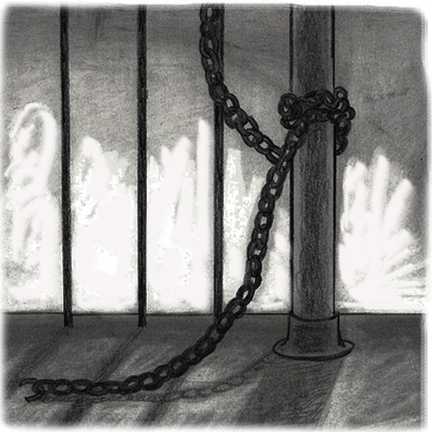
Then he saw that Sharon had escaped. His howls filled Centre Block to the rafters.

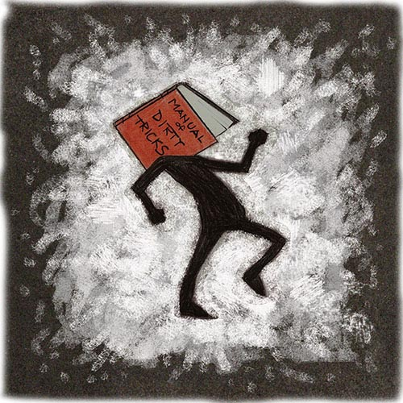
“I hate you Parliamentary Budget Officer. I hate you most of all!”

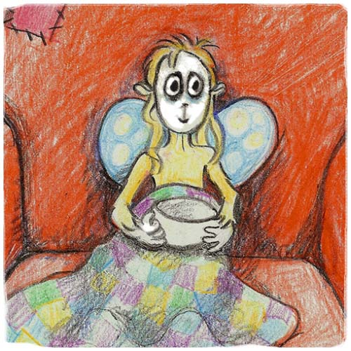
And so it happened that Sharon crawled into the broom closet where, after weeks of starvation, loneliness and pain, she’d finally been rescued.

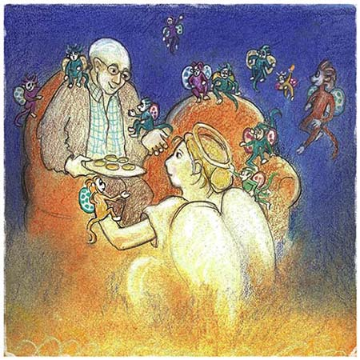
Sharon isn’t the only one sharing Better Angel’s tiny room. There are dozens of refugee scruples from the House of Commons, various Government Ministries, institutions, businesses and industries.

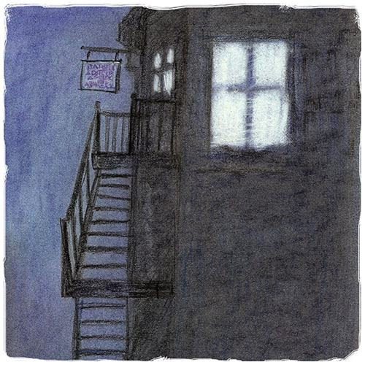
Although the dark days of winter are with us, a bright light shines from a tiny bed-sit in Ottawa. Better Angel has set up an adoption service for abandoned scruples. You might find ads in your local newspaper. I saw one yesterday.
“Sharon is a lovely scruple with golden fur and a long pedigree. She loves the truth and gets along with thoughtful children, adults and other pets. She’d make a great companion to any family, school, institution, business or government.”

